MongoDB Task

1.Find all the information about each products ?

Answer;

db.product.find()

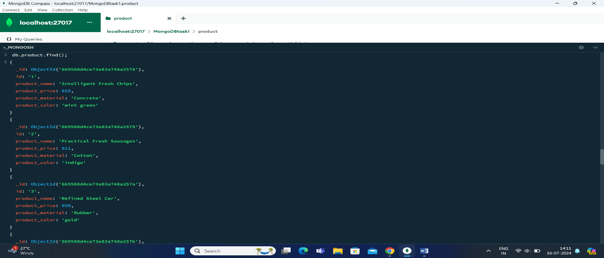

2. Find the product price which are between 400 to 800 ?

Answer ;

db.product.find({product_price:{$gte:400 , $lte:800}});

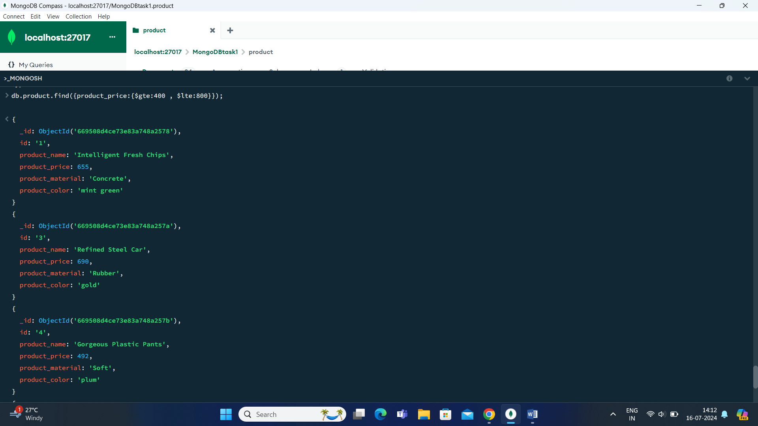

3. Find the product price which are not between 400 to 600 ?

Answer;

db.product.find({product_price:{$not:{$gte:400 , $lte:800}}});

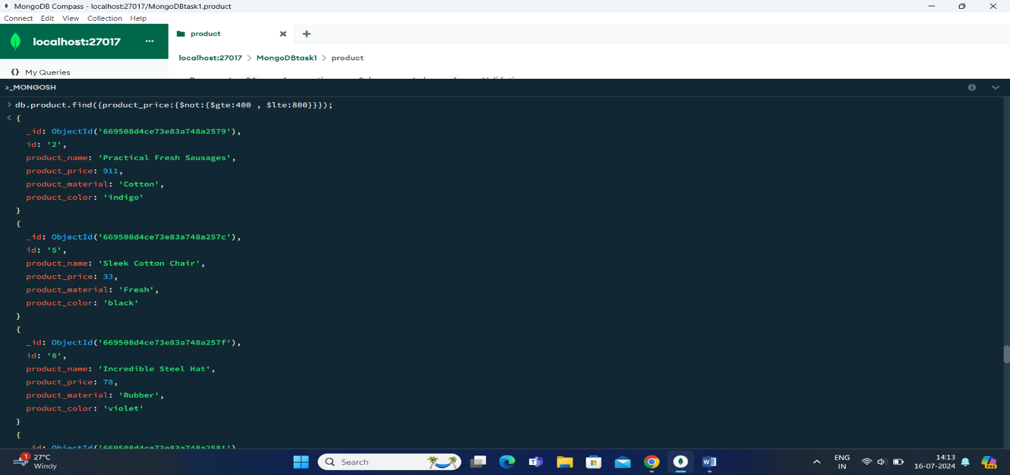

4. List the four product which are greater than 500 in price ?

Answer ;

db.product.find({product_price: { $gt: 500 }}).sort().limit(4);

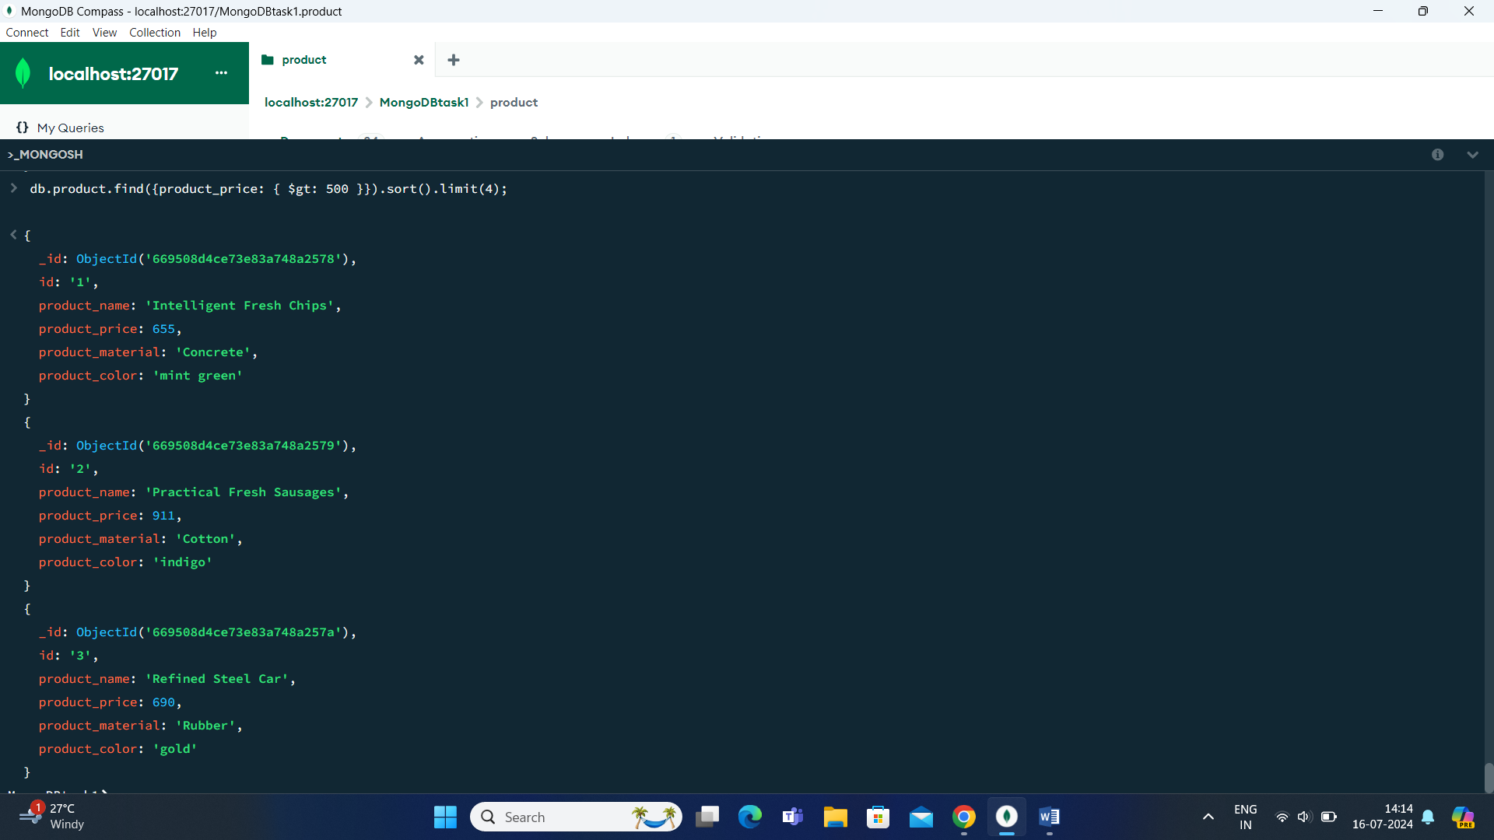

5. Find the product name and product material of each products ?

Answer;

db.product.find({}, { product_name: 1, product_material: 1 });

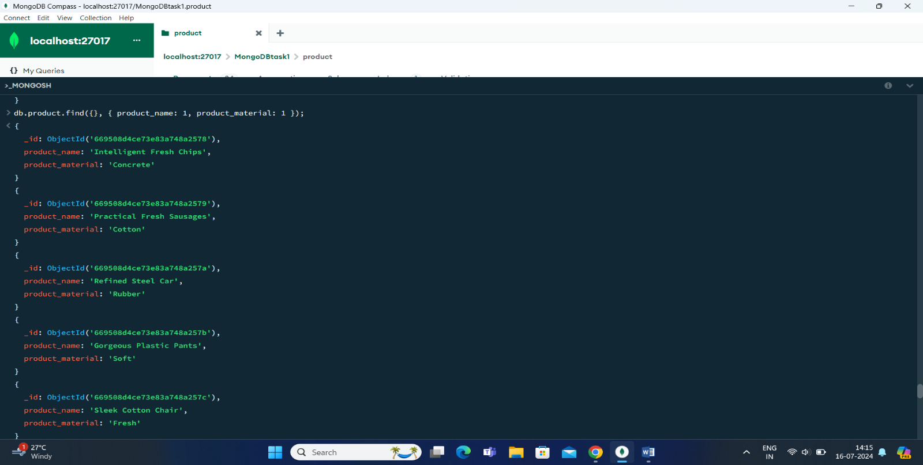

6. Find the product with a row id of 10 ?

Answer ;

db.product.findOne({id:’10’});

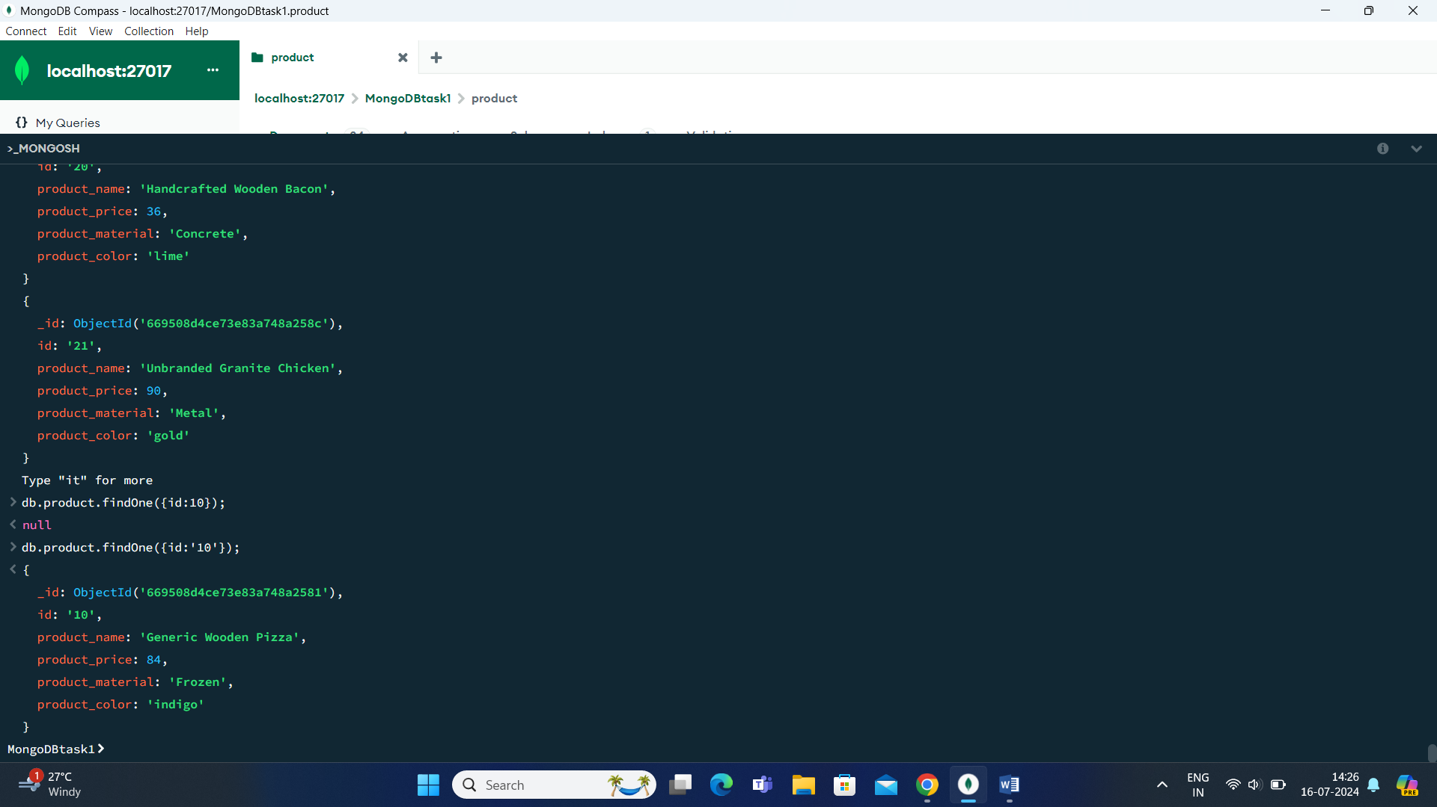

7. Find only the product name and product material ?

Answer ;

db.product.find({}, { _id:0, product_name: 1, product_material: 1 });

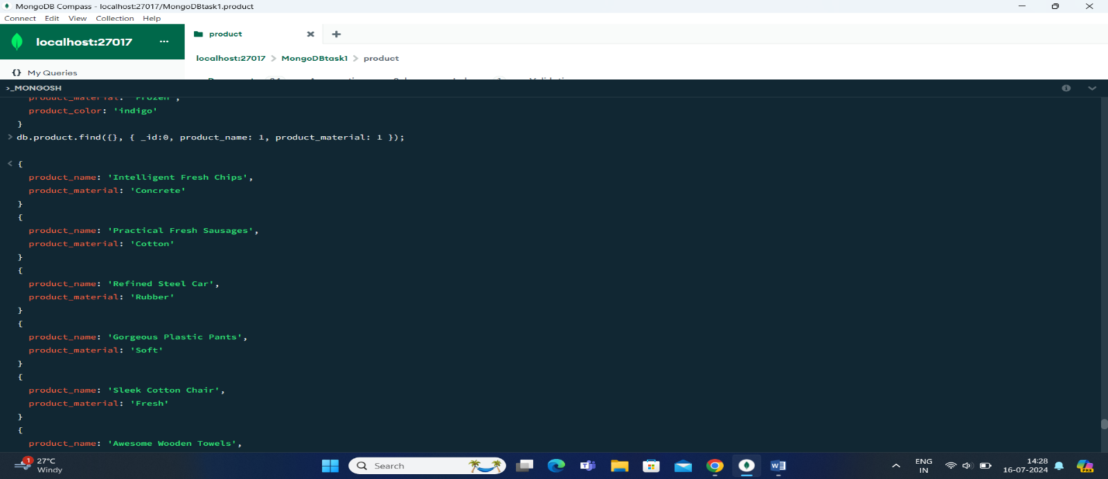

8. Find all products which contain the value of soft in product material ?

Answer ;

db.product.find({ product_material: /soft/i });

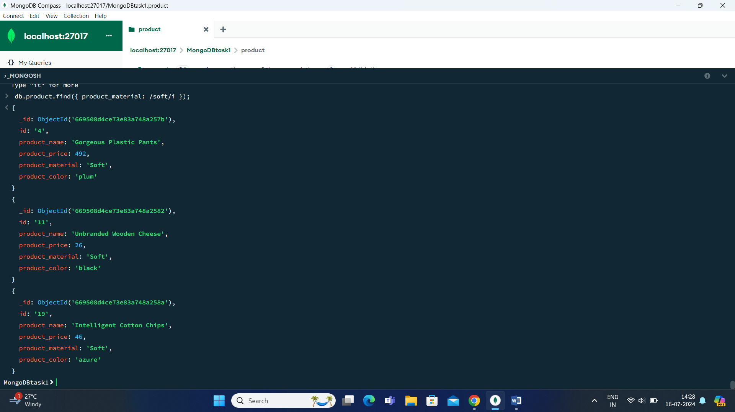

9. Find products which contain product color indigo  and product price 492.00 ?

Answer ;

db.product.find ({ productColor: "indigo",price: 492.00});

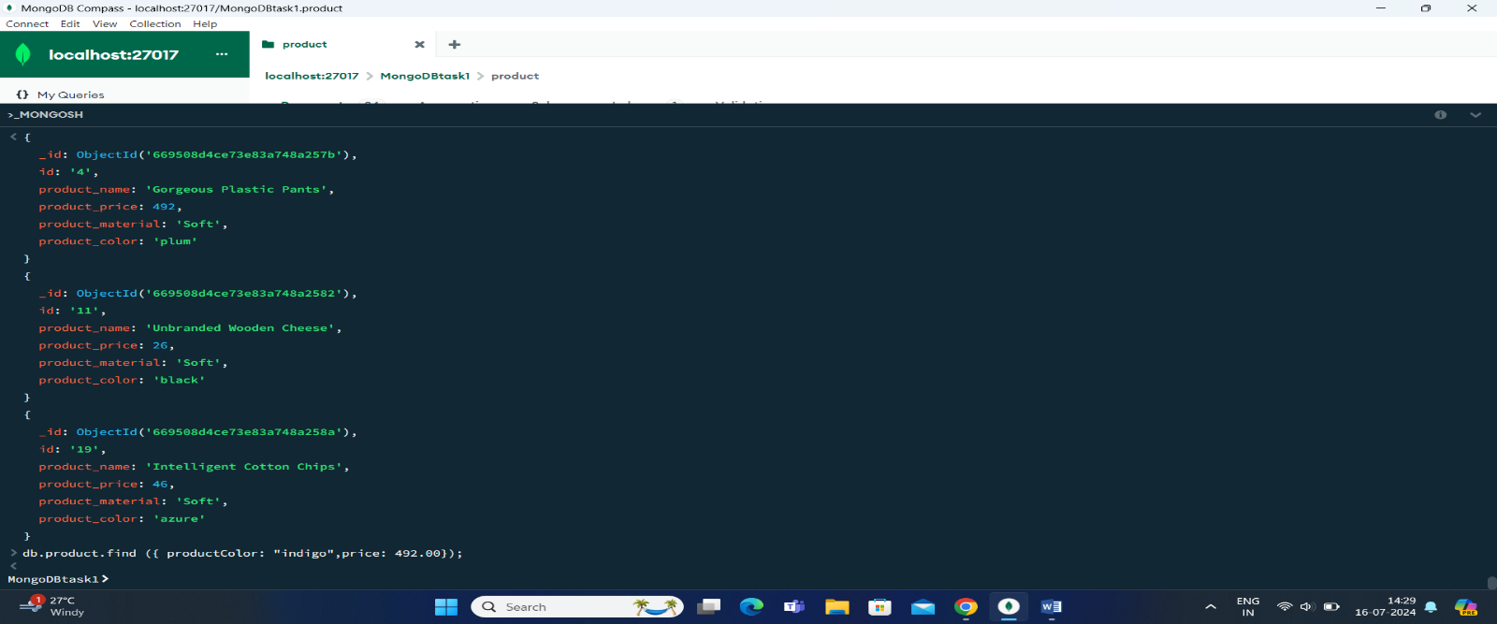

10.Delete the products which product price value are 28 ?

Answer;

db.product.deleteMany({ price: 28 });

